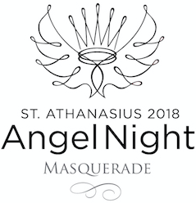

Angel Night News

The Angel Night Team is hard at work pulling together the details of our Angel Night Masquerade, and we still need some help from our community.

Auction Donations
Please consider an auction donation, contributing to the wine cellar, or considering a monetary donation to help us build a successful event. Link here for the Donation Form. Auction Deadline March 24th .

Silent Auction Wish List
We are still in need of vacation homes, weekend getaways, sports tickets, golf foursomes and one-of-a-kind items. For more details visit the Angel Night Page on our school website. You can also find it by going to Alumni & Giving>Fundraising>2018 Angel Night Masquerade.

Wine Cellar
Consider donating wine to the St. A’s Wine Cellar, which will be auctioned off at the event. Contact Mick at Shaefer’s Wines 847.677.9463 to add to our auction collection. Contact Jaime at jaimevehovsky@yahoo.com if you prefer to donate from your personal cellar. Wine donation deadline is March 30th.

With spring in the air we are looking forward to celebrating with all of you at the Angel Night Masquerade. The event is not a costume party but a masquerade theme. Cocktail attire; masks are encouraged, but optional.

Thank you for supporting Angel Night!

~The Angel Night Team

